Configuring Automatic Approval
Another option that administrators can set is the ability to automatically configure updates for automatic approvals. To set this up, administrators would complete the following steps:

1. Open the Microsoft Intune administration console. Then click the Configure Updates link.
2. In the Automatic Approval Rules section (see Figure 6.25) under the Server Settings:
Updates page, click the New button.
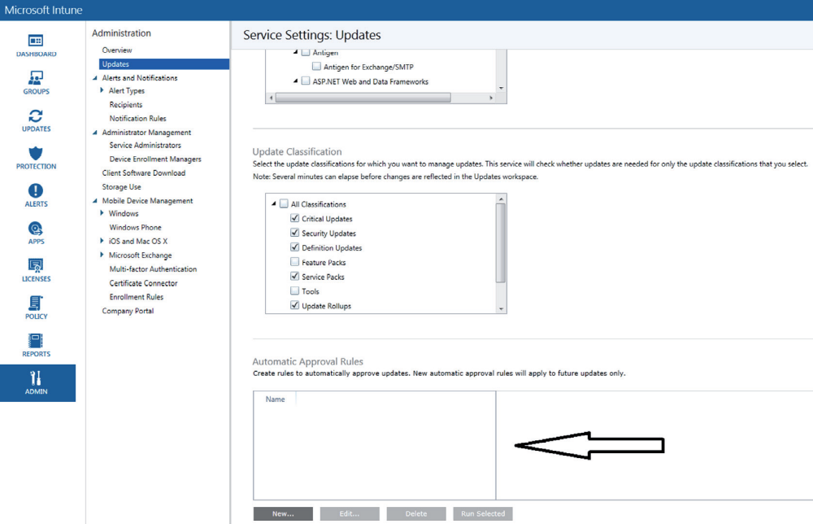

3. On the General page, type in the approval rule name and optional description. Click Next.
4. On the Product Categories page, select the products for which you want to have automatic
updates. Click Next.
5. On the Update Classifications page, choose the update classifications that have automatic
approval. Click Next.
6. On the Deployment page, choose the devices that these automatic approvals will apply
to and click Add. Click Next.
7. On the Summary page, review your settings and then click the Finish button.

To deploy software updates to non-Microsoft vendors, you would use the Upload
Update Wizard. The Upload Update Wizard helps an administrator get their updates into
the cloud storage space. After they are uploaded, administrators can then approve or deny
the updates to specific groups. To launch the Upload Update wizard, you would click the
Add Updates link (see Figure 6.26). 